**‘AccessBank DBA Internship Program’**

**Project 19: Find the longest running query using Extended Events**

The IT director has informed you that users are complaining that it’s taking too long for them to get a result set back from their application. The IT director has asked to find out why there are spikes in the memory and CPU usage and what is causing this resource consumption.

It is your task to find out what query is causing this query. You must use Extended Events, not SQL Profiler.

Disclaimer!!!

If you want to use GUI, then it is preferable to use New Session… instead of New Session Wizard

(For more info please visit the below link:

<https://docs.microsoft.com/en-us/sql/relational-databases/extended-events/quick-start-extended-events-in-sql-server?view=sql-server-ver15>)

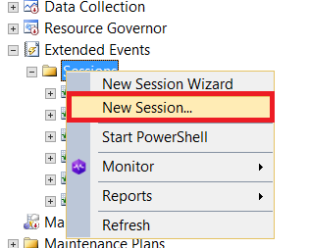

Your extended event session must have the following properties:

1. SESSION name on the server must be Long Running Queries.

**Firstly, I collapsed Management->Extended Events->Sessions and in here I right clicked to get dropdown list and from here I selected New Session… rather than New Session Wizard for creating session by using GUI because of your recommendation. Then, I named it Long Running Queries.**

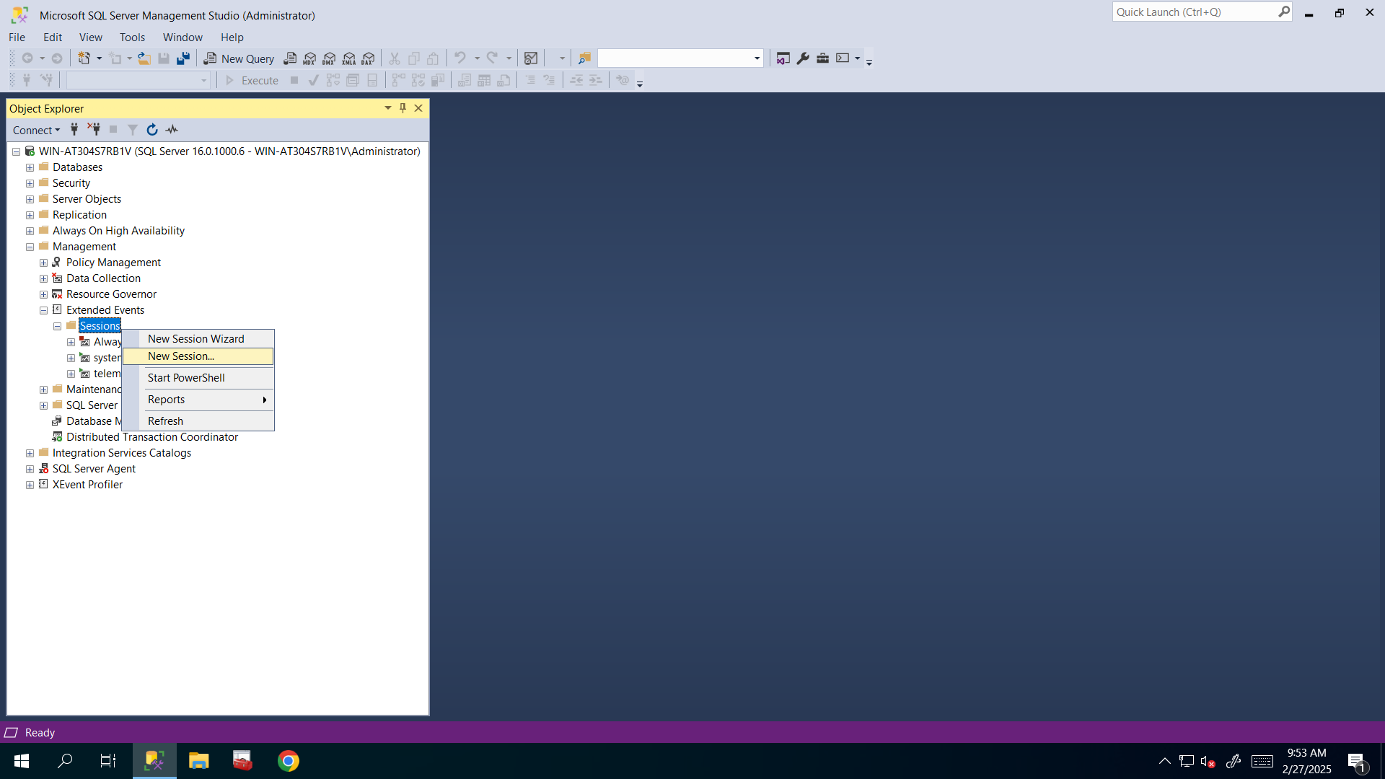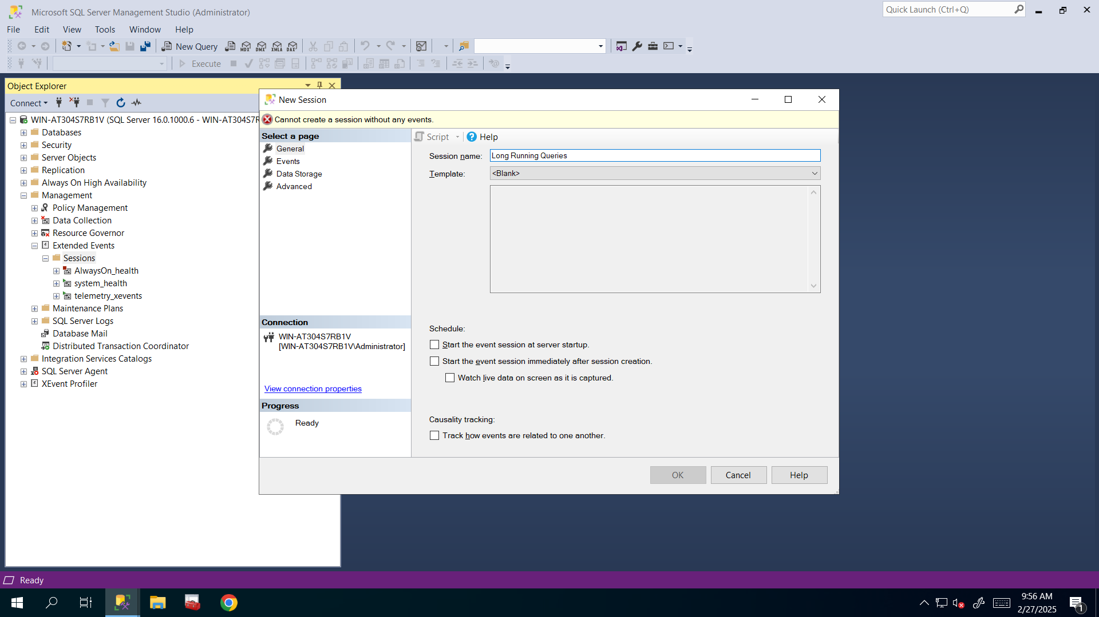

1. Add one EVENT from sqlserver PACKAGE for capturing SQL statements.

**I filtered package to see sqlserver package’s events**.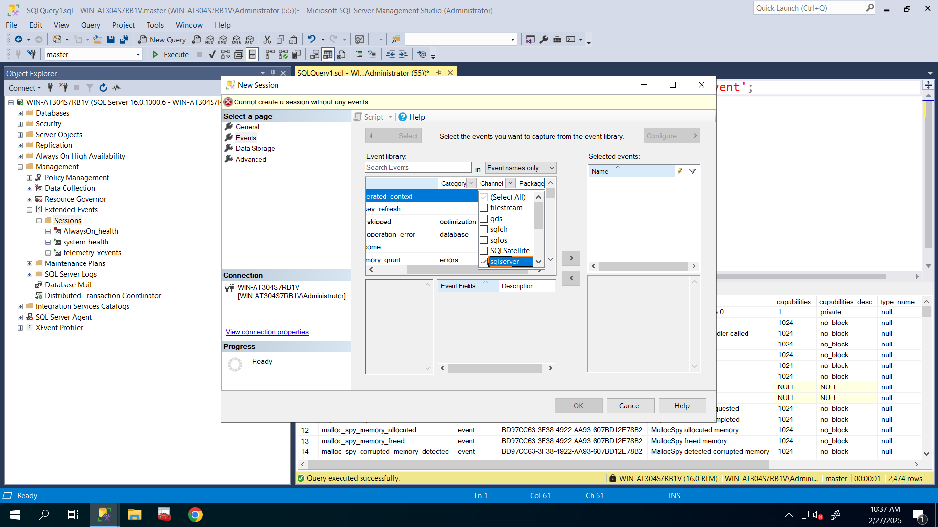

**And here I needed sql statement completed event so I searched it and after finding it I clicked on it to select and clicked right arrow button to add that event and then clicked Configure button to configure its event fields, predicates, actions and so on**.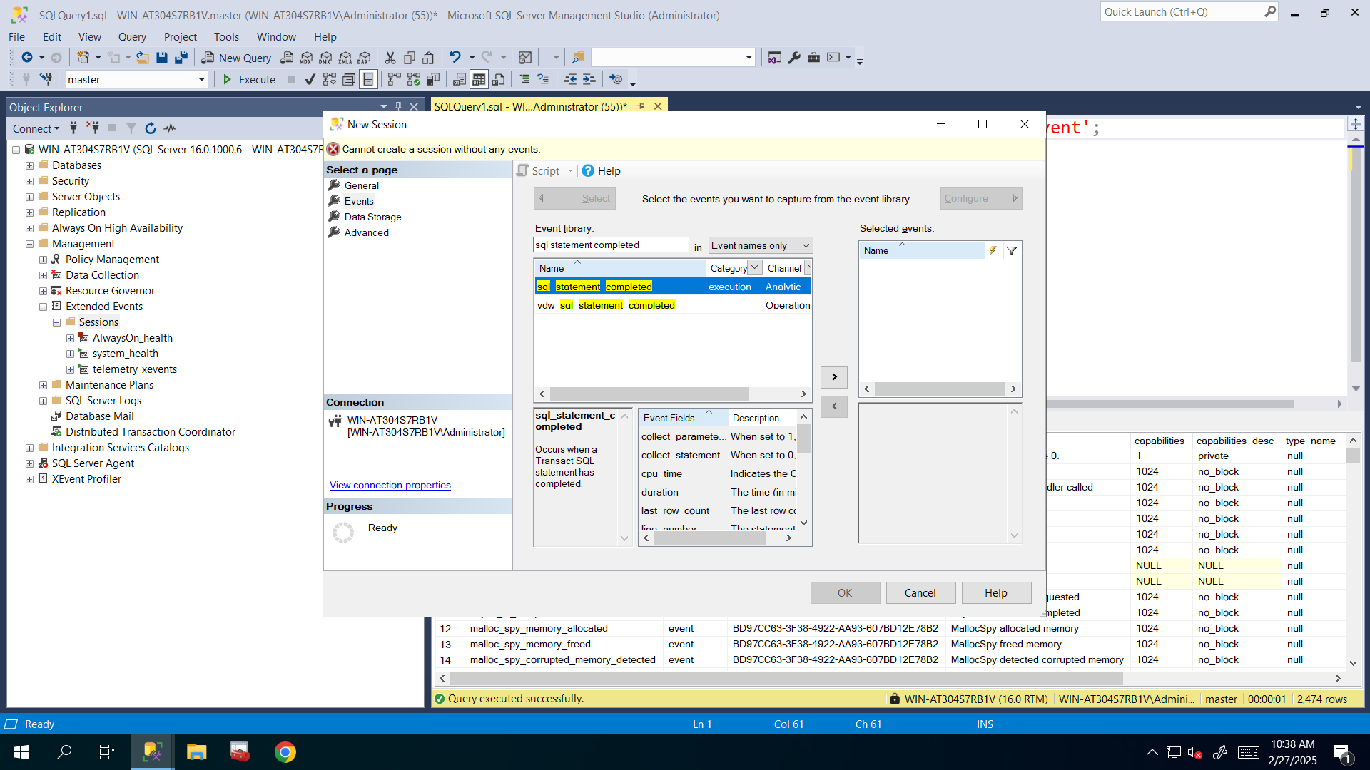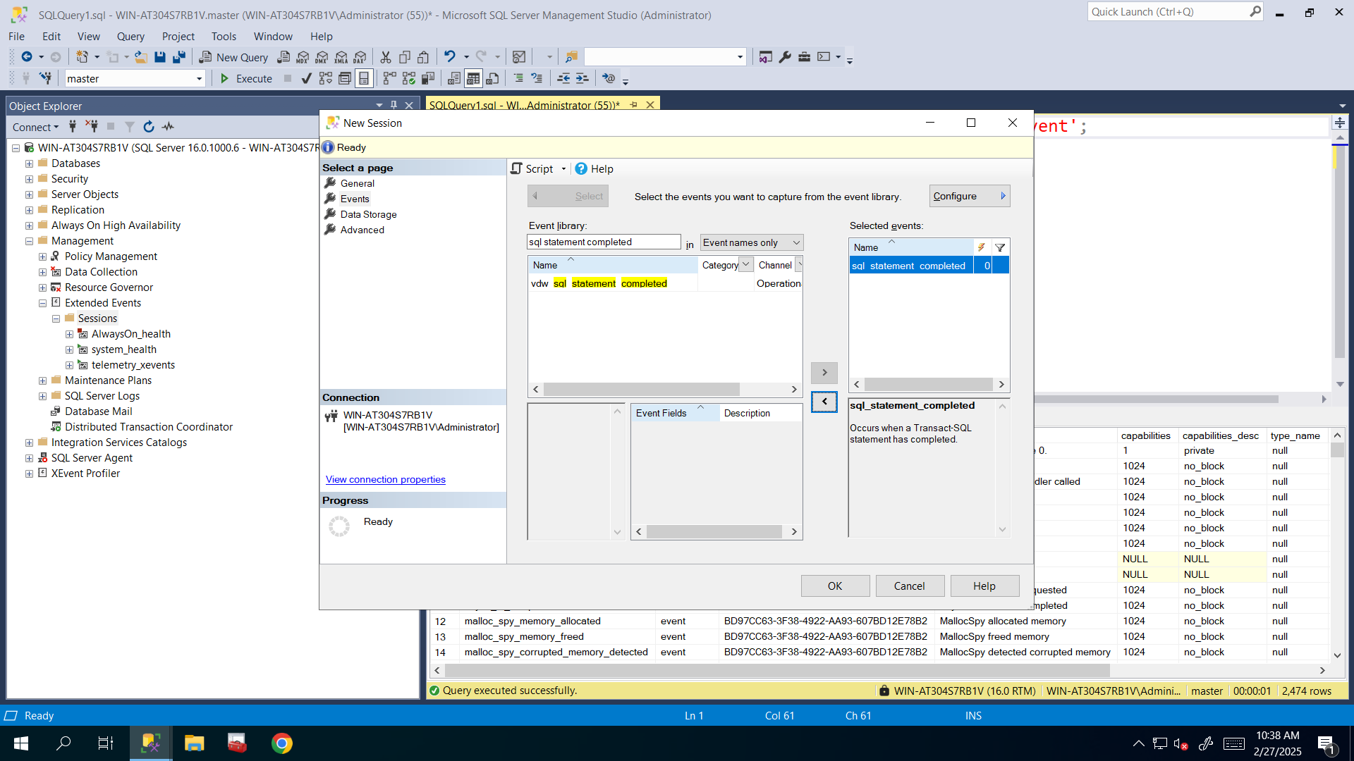

1. ACTIONS or GLOBAL FIELDS: database name, application name, session id, principal name (means server level) and username (means database level).

**I selected all of these needed actions**: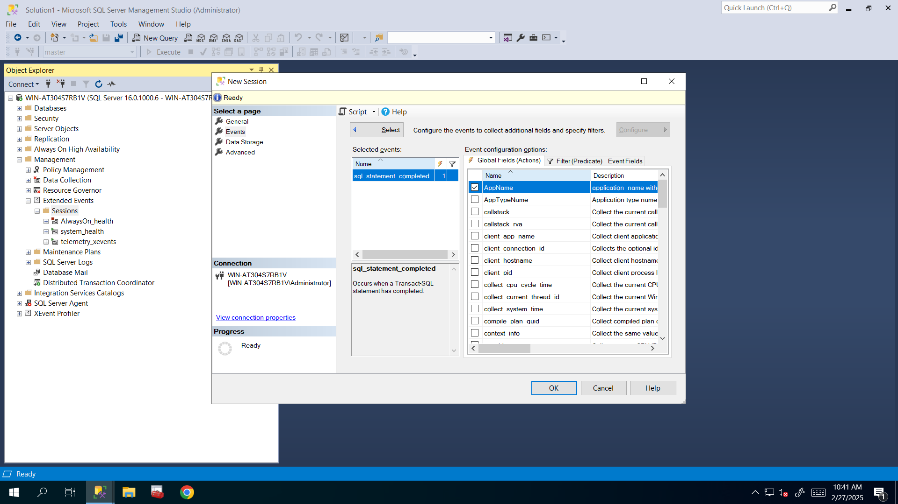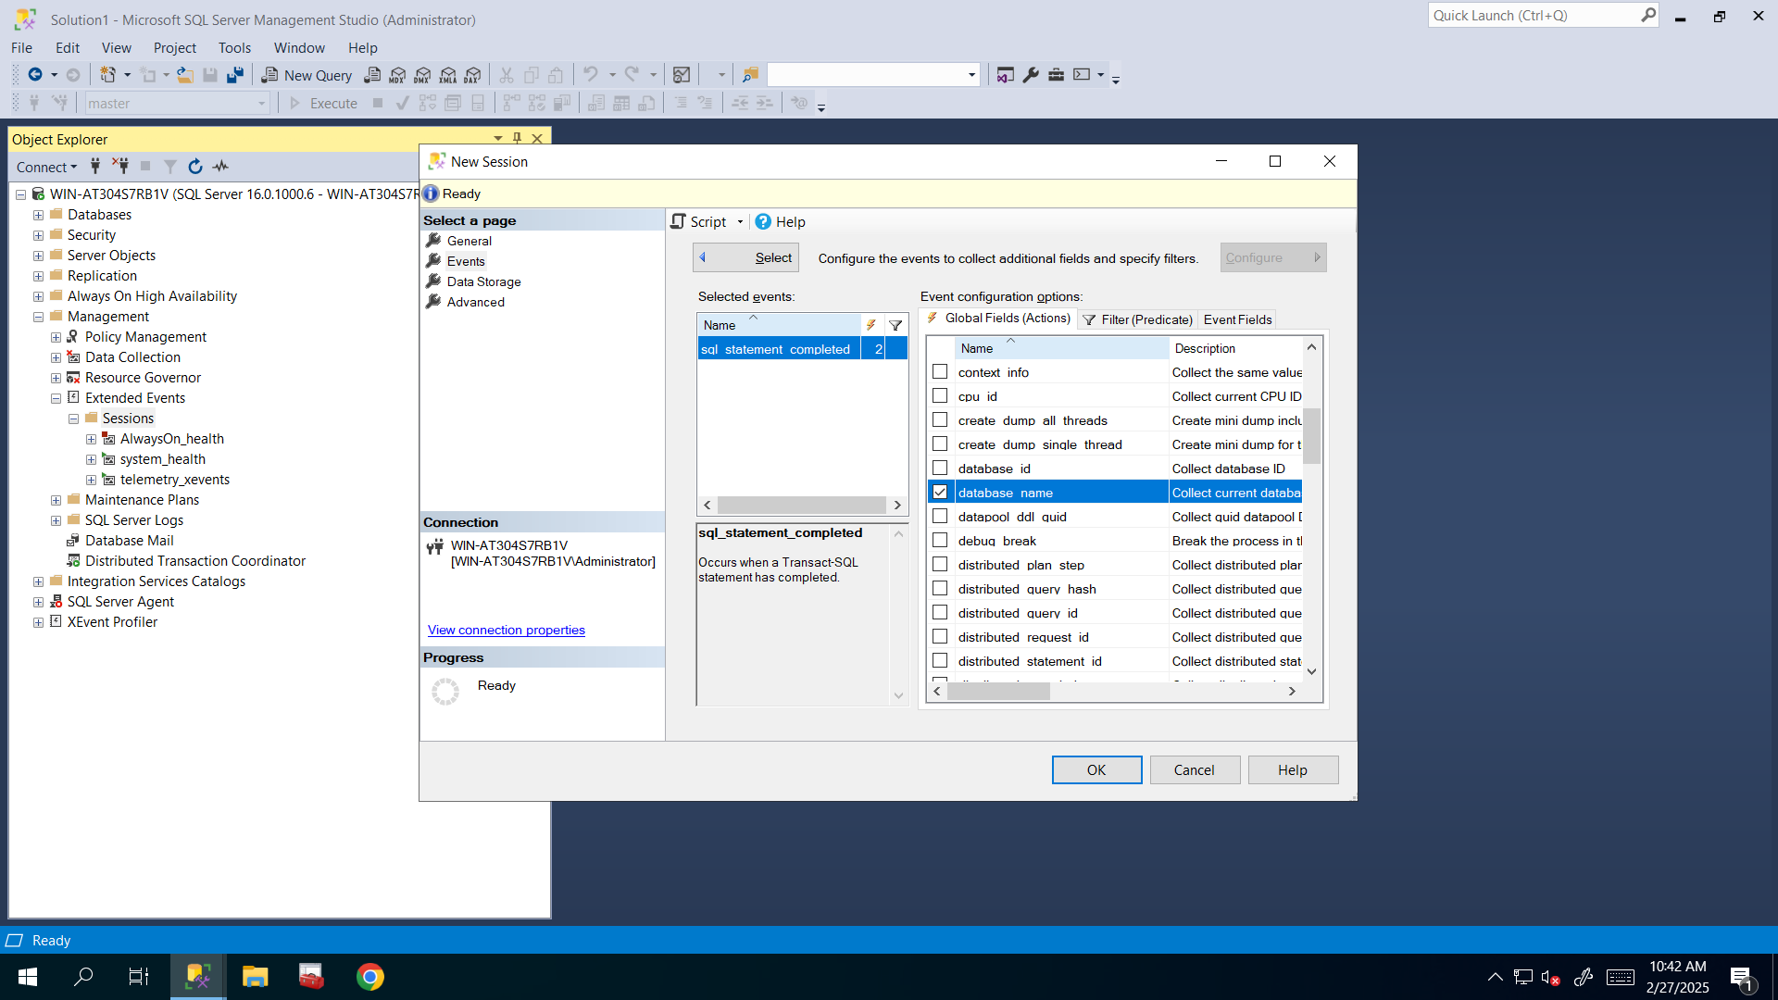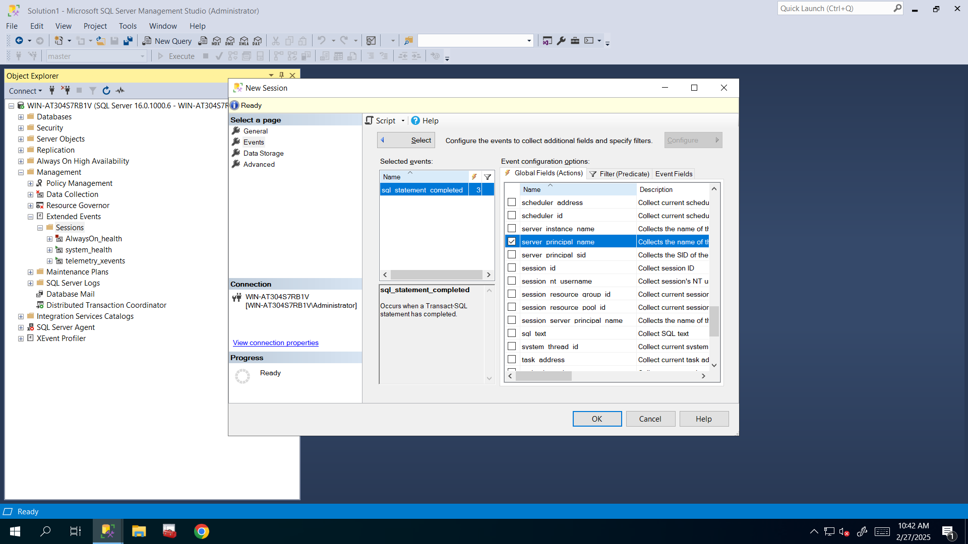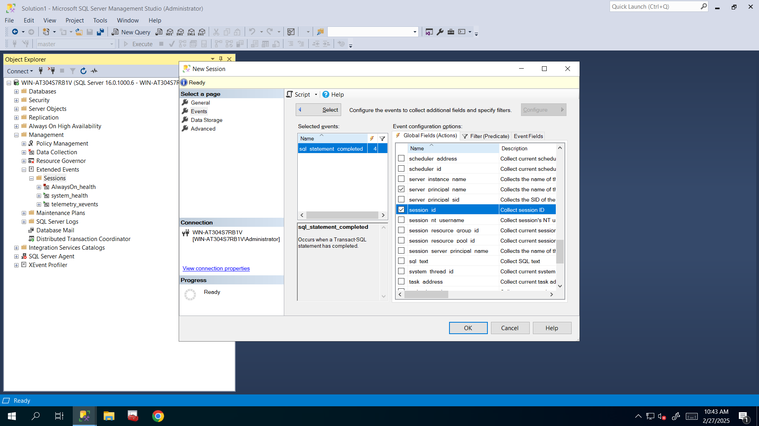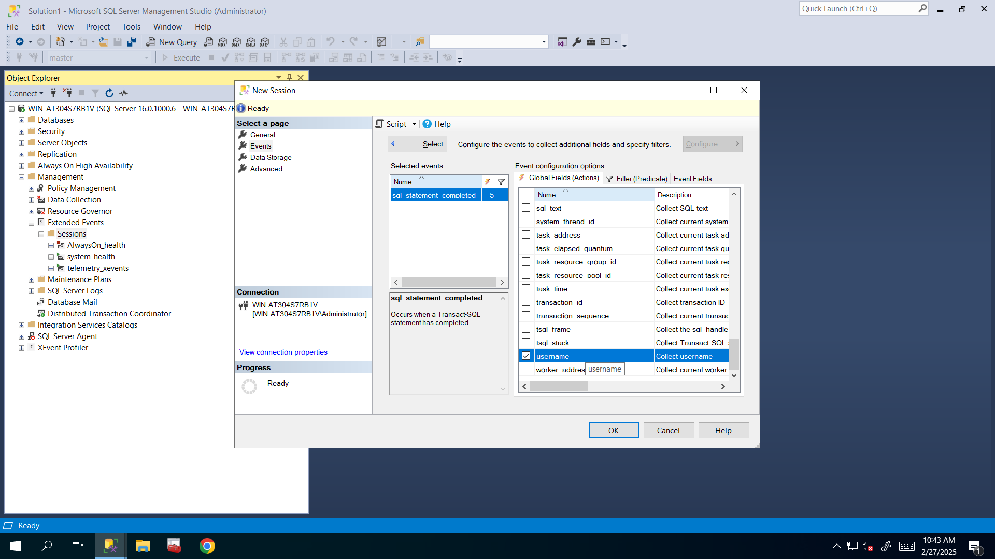

1. Alongside ACTIONS, we also need to capture some EVENT FIELDS such as duration, cpu_time, physical_reads, logical_reads, writes, row_count, and actual statement during the query execution. Do not worry, these event fields are automatically captured. No extra work is needed. You can just view them from:

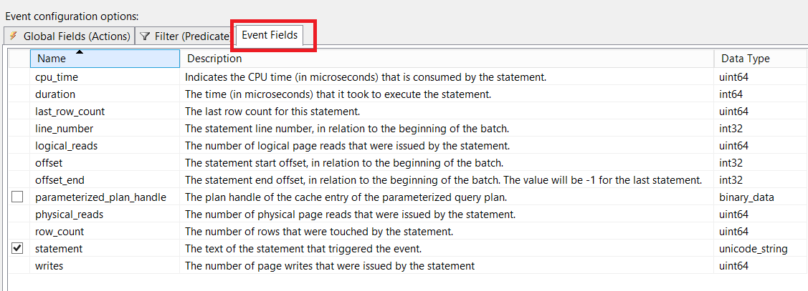

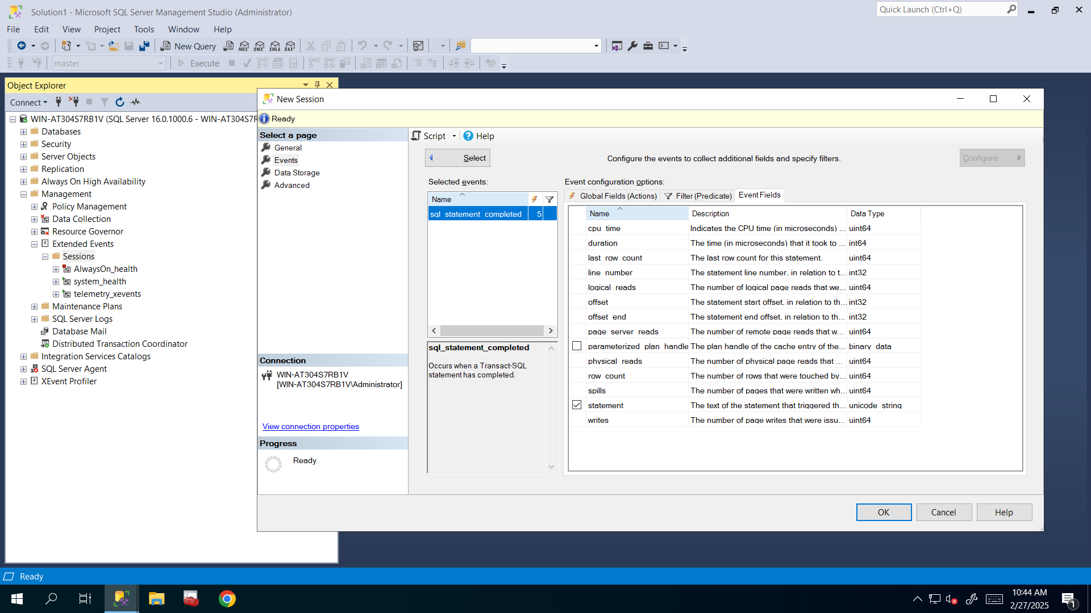

**I viewed them and as you said I didn’t do anything here.**

Or using the below query:

SELECT p.name package_name,

o.name event_name,

c.name event_field,

c.type_name field_type,

c.column_type column_type

FROM sys.dm_xe_objects o

JOIN sys.dm_xe_packages p ON o.package_guid = p.guid

JOIN sys.dm_xe_object_columns c ON o.name = c.object_name

WHERE o.object_type = 'event' and

column_type not in ('readonly','customizable')

order by package_name, event_name

1. Filter by database name and duration (PREDICATES). We need to capture queries which take more than 15 seconds to run on AdventureWorks2014 database.

**I filtered it by database name when it equals to AdventureWorks2014 and by duration when it is greater than 15.000.000 microseconds that means 15 seconds.**

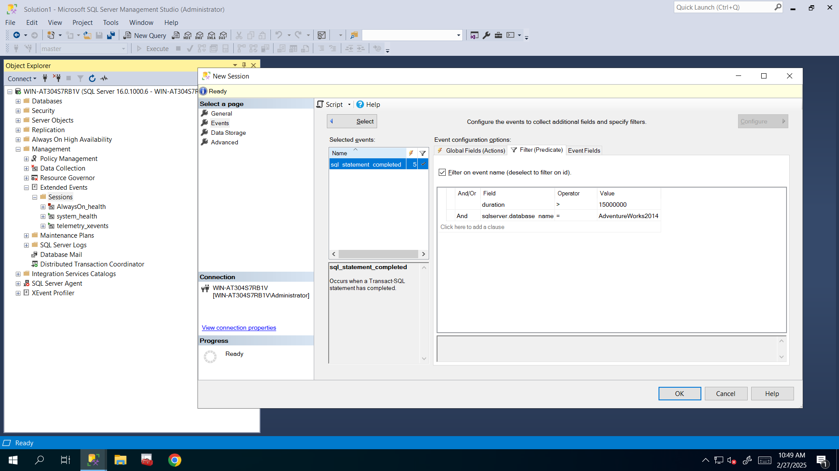

1. Choose file with 10 MB size as a TARGET to save the captured data.

**Here I selected event file as target and configured to 10MB for Maximum file size.**

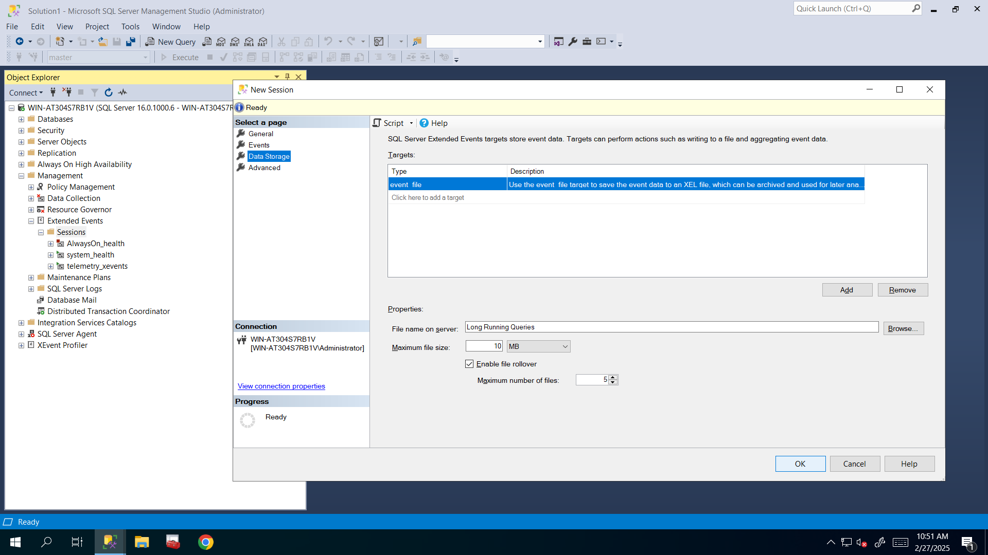

1. Leave other settings as default.
2. Go to sessions and start your session.
3. Execute the long running query below:

SELECT TOP 2000000 *

FROM Production.TransactionHistory th

INNER JOIN

Production.TransactionHistoryArchive tha

ON th.Quantity = tha.Quantity

**I left other settings as default and clicked OK to create that session and went to sessions and started my session.**

**After starting and refreshing sessions, I saw that red square icon turned into green triangle icon that means it’s started and running so it will capture all long running queries that execute more than 15 seconds in AdventureWorks2014 database.**

**After these, I executed above query that took 1 minute 35 seconds to run and I used AdventureWorks2014 database so my Long Running Queries session must capture that data and store it inside event file.**

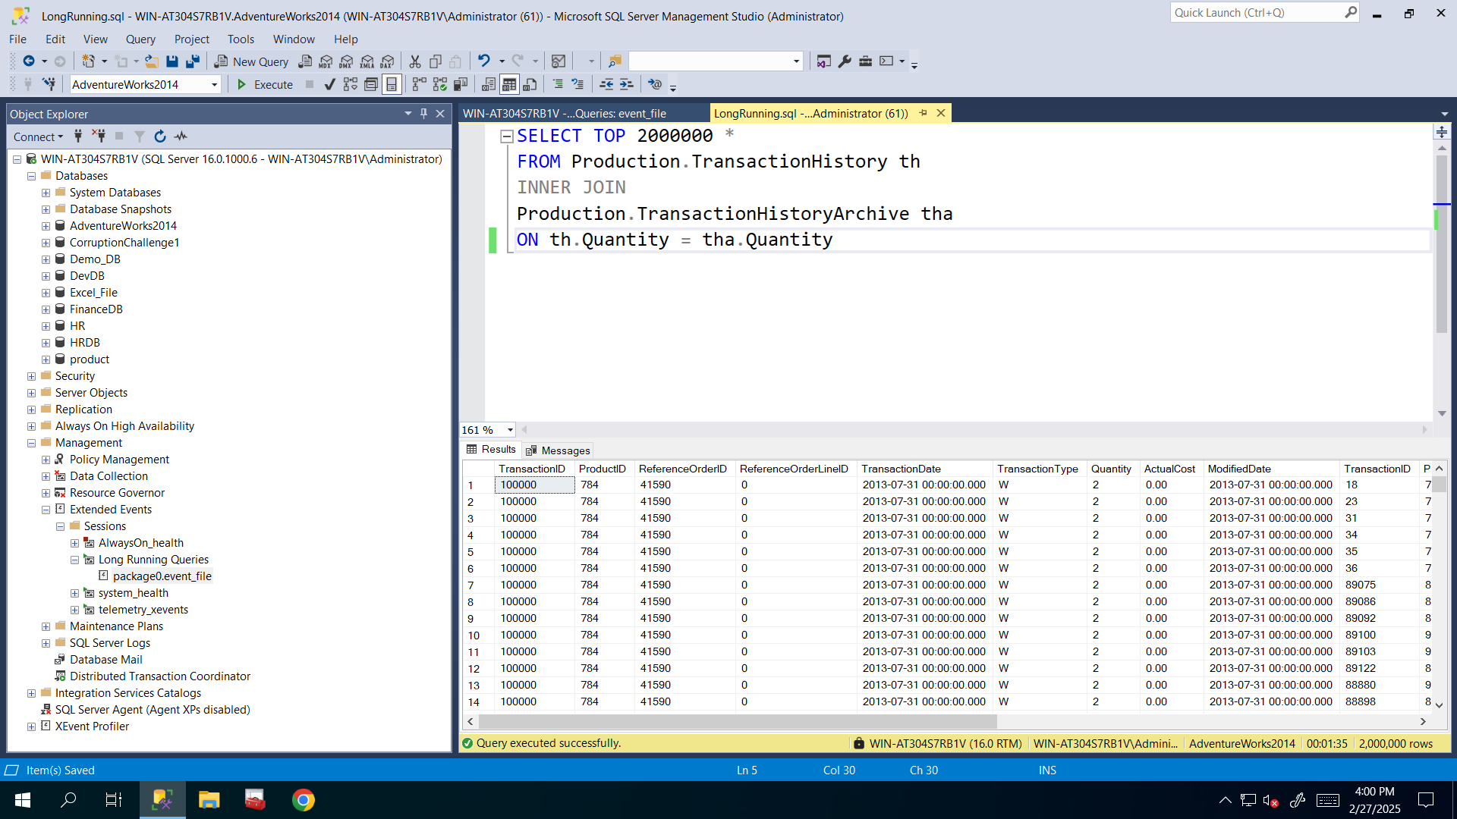

1. Verify the captured data.

**I verified that by going to my session and expanded to see its event file and here I selected View Target data to see captured data and I saw that it’s captured successfully**.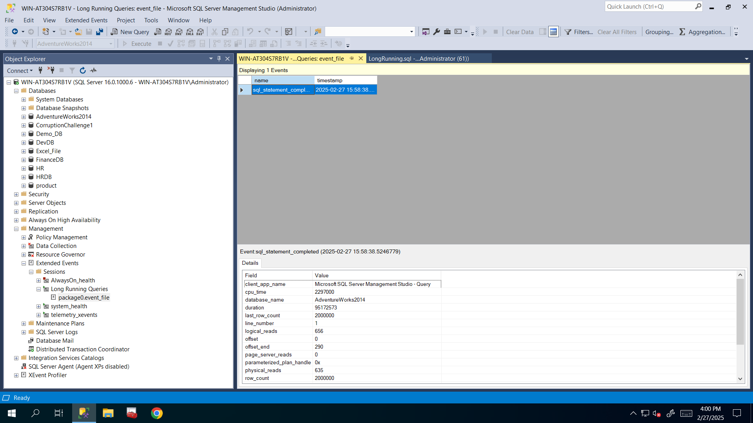

Hint 1: Extended Event Structure

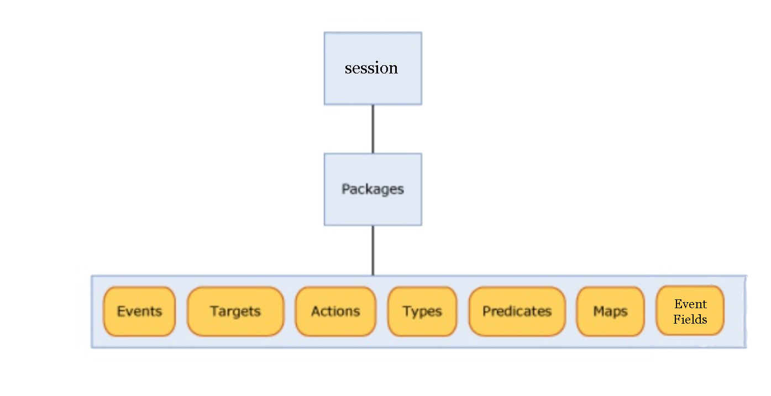

Hint 2:

Duration in Extended Events is measured in microseconds